Design and Development of Office Student Affairs (OSA) Management System with QR Code and Geotagging System for Student Activity and Attendance

Bachelor of Science in Information Technology
St. Rita’s College of Balingasag



In Partial Fulfillment of the Requirements for the Degree Bachelor of Science in Information Technology

Hannah Felexabeth G. Abao
Maricar T. Bahala
Ishi Trixie Loraine G. Regodon
Joshua Angelo Arquita

September 2026
CHAPTER 1

1.1 Background and Rationale
Technology plays an important role in strengthening governance and improving educational quality by enhancing information access and streamlining institutional processes. Higher education institutions increasingly adopt digital systems to organize records, monitor student participation, and support data-driven decision-making (Al-Fedaghi, 2019; Chen & Martinez, 2024). Among these innovations, QR-code-based attendance systems enable fast verification and real-time data capture, while geotagging technology enhances attendance authenticity by recording the geographic location of users through Global Positioning System (GPS) services. By validating whether a student is physically present within an authorized location, geotagging helps reduce proxy attendance, improve accountability, and strengthen the reliability of attendance records in educational institutions (Kessler, 2021; Kamarainen et al., 2018; Davies et al., 2023). The integration of QR codes and geotagging therefore provides a more secure and efficient approach to attendance monitoring compared with traditional manual methods.
At St. Rita's College of Balingasag (SRCB), the Office of Student Affairs (OSA) currently manages student activity attendance, evaluation forms, admission slip requests, and participation records using a combination of manual documents and separate digital platforms. Based on interviews and observations conducted by the researchers with the OSA personnel, attendance is primarily recorded using paper attendance sheets before being encoded into digital files, while activity evaluations are managed through separate Google Forms. Based on interviews conducted with the Office of Student Affairs personnel of St. Rita's College of Balingasag, retrieving attendance and student records may take one to three days due to manual record handling. Furthermore, the current process does not provide a mechanism for verifying whether students are physically present within the designated activity venue during attendance checking. The use of disconnected processes also makes it difficult to consolidate attendance, evaluation results, and participation records into a single repository, resulting in additional administrative workload and delays in generating reports.
These operational challenges affect the efficiency of the Office of Student Affairs and limit its ability to provide timely and accurate student services. Delays in attendance verification, fragmented record management, the absence of location validation, and the lack of an integrated evaluation process reduce the effectiveness of monitoring student participation and supporting institutional decision-making. To address these concerns, the researchers proposed the "Design and Development of Office Student Affairs (OSA) Management System with QR Code and Geotagging System for Student Activity and Attendance". The proposed system integrates QR code-based attendance, geotagging validation, digital activity evaluations, OSA-approved admission slip requests, late attendance monitoring, student case record management, automated e-certificate generation, and analytics within a single web-based platform. The system is expected to benefit the Office of Student Affairs by improving administrative efficiency and record management, Program Heads by providing real-time monitoring of student participation, Central Student Government (CSG) officers by simplifying attendance monitoring during activities, students by providing faster and more convenient access to OSA services, and St. Rita's College of Balingasag by promoting a more accurate, transparent, and technology-driven student affairs management system.

1.2 Statement of the Problem
The Office of Student Affairs (OSA) of St. Rita's College of Balingasag manages student activity attendance, evaluation forms, admission slip requests, and participation records through separate manual and digital processes. These disconnected procedures result in delays in attendance verification, record retrieval, and report generation, while making it difficult to monitor late attendance and verify students' physical presence during activities. In addition, activity evaluations are not consistently linked to student participation, and certificates are generated manually, increasing the administrative workload. Consequently, these challenges lead to inefficient workflows, fragmented record management, and reduced efficiency in OSA operations.

1.3 Objectives

General Objective
The general objective of this study is to design and develop a Office Student Affairs (OSA) Management System with QR Code and Geotagging System for Student Activity and Attendance for the Office of Student Affairs (OSA) of St. Rita's College of Balingasag.

Specific Objectives
Specifically, the study aims to:
- Gather Data by conducting system requirement gathering through interviews, observations, and stakeholder consultations to identify operational needs, analyze existing processes, and define the initial Product Backlog using Agile requirement documentation techniques and stakeholder analysis tools.
- Planning and Designing by designing the system interface and workflow using Figma, developing and prioritizing the Product Backlog through Agile Scrum methodology using project management tools and organizing system features including QR-based attendance, geotagging validation, evaluation forms, admission slip processing, student case record management, e-certificate generation, analytics dashboard, and role-based access control.
- Development by implementing iterative system development through the Agile Scrum framework using structured 1–4 week sprints, conducting daily Scrum meetings, and developing the system using PHP, Laravel, HTML, CSS, React, and MySQL.
- Continuous Integration by integrating completed system modules throughout each sprint, conducting sprint reviews and stakeholder demonstrations to validate implemented features, gathering feedback for Product Backlog refinement, performing sprint retrospectives to improve succeeding iterations, and managing source code using Git and GitHub.
- Testing by performing continuous Functional Testing, Integration Testing, Usability Testing, and Security Testing using manual testing techniques and Laravel built-in testing tools, and deploying validated system increments through Apache using XAMPP and/or cloud hosting until the QR Code and Geotagging System for Monitoring OSA and Student Activity, Attendance, and Evaluation is fully operational.

1.4 Scope and Limitation
This study focuses on the development of the Office Student Affairs (OSA) Management System with QR Code and Geotagging System for Student Activity and Attendance within the St. Rita's College of Balingasag Higher Education Department. The system is intended for use by the Office of Student Affairs (OSA) Administrator, Central Student Government (CSG) Officers, Program Heads, and students. It provides functionalities such as QR code-based attendance monitoring, geotagging validation for attendance within the school premises, late attendance tracking, student evaluation management, OSA-approved admission slip processing, student violation and case record management, and automated e-certificate generation. The system also provides an analytics dashboard that supports real-time monitoring, report generation, and data-driven decision-making. The system is developed as a web-based application and will be accessible online through desktop computers, laptops, tablets, and smartphones using supported web browsers.
The proposed system is limited to OSA-related services and does not cover academic grading systems, enrollment systems, or learning management systems. It does not integrate with existing institutional databases; instead, the system maintains its own database and stores only records created after deployment. Each student is assigned one unique QR code that serves as the official identifier for attendance monitoring and authorized system transactions. Existing paper-based records are not automatically migrated and require manual encoding into the system. The minimum hardware requirements include desktop or laptop computers with at least an Intel Core i3 (or equivalent dual-core processor), 8 GB RAM, and Windows 10 or later, or macOS 11 (Big Sur) or later, while smartphones should support modern web browsers and have access to a QR code scanner for attendance transactions. The recommended hardware requirements include computers with an Intel Core i5 (or higher), 16 GB RAM, and a solid-state drive (SSD) for improved system performance, together with dedicated 2D QR code scanners for faster and more reliable attendance processing during large-scale activities. The system is best accessed using updated web browsers such as Google Chrome version 120 or later, Mozilla Firefox version 120 or later, Microsoft Edge version 120 or later, or Safari version 17 or later.

1.5 Significance of the Study
The proposed Development of Office Student Affairs (OSA) Management System with QR Code and Geotagging System for Student Activity and Attendance aims to improve the management of student affairs by integrating attendance monitoring, geotagging validation, evaluation processing, admission slip management, and record management into a single web-based platform. The system is expected to enhance the efficiency, accuracy, and reliability of administrative processes while reducing manual work, minimizing human errors, and improving record accessibility. Through real-time monitoring and automated reporting, the proposed system supports a more organized, transparent, and technology-driven approach to managing student activities and services.
This study is significant to the following:
- Office of Student Affairs (OSA)
The system will benefit the Office of Student Affairs (OSA) by providing centralized student records, real-time attendance monitoring, admission slip management, evaluation management, student case management, analytics, and automated report generation.
- Program Head
The system will benefit the Program Heads by providing real-time access to student attendance, participation records, case records, evaluation results, and program-based monitoring reports.

- Central Student Government (CSG) Officers
The system will benefit the Central Student Government (CSG) Officers by providing QR code attendance monitoring, event participation tracking, and efficient activity management.

- Students
The system will benefit students by providing faster attendance verification, digital admission slip requests, activity evaluations, access to participation records, and automated e-certificates.
- The Institution (St. Rita’s College of Balingasag)
St. Rita’s College of Balingasag, particularly the Office of Student Affairs (OSA) Office and the Higher Education Department, by providing a centralized student affairs management system, improved record management, real-time monitoring, and data-driven administrative reporting.
- Future Researchers
The study will benefit future researchers by serving as a reference for developing and improving student affairs management systems, QR code attendance systems, geotagging applications, digital evaluation systems, admission slip processing, and e-certificate generation.

1.6 Definition of Terms
This section defines the technical and operational terms used in this study to provide clarity and ensure a common understanding of the concepts discussed. These terms will be used throughout the development and evaluation of the proposed design and development of Office Student Affairs (OSA) Management System with QR Code and Geotagging System for Student Activity and Attendance.

- Agile Scrum Methodology – An iterative software development framework used in this study to manage system development through short development cycles called sprints, allowing continuous improvement and stakeholder feedback.
- Application Programming Interface (API) – A set of rules and protocols that enables communication and data exchange between different software applications and system components.
- Geotagging – The process of capturing and recording a user's geographic location using GPS technology. In this study, geotagging is used to verify that students are physically present within the authorized school premises during attendance checking.
- Global Positioning System (GPS) – A satellite-based navigation system that determines the geographic location of a device. It is used in the proposed system to support geotagging and location validation.
- Hypertext Markup Language (HTML) – The standard markup language used to create and structure web pages displayed through web browsers.
- Laravel – An open-source PHP framework used for developing the backend components of the proposed system. It provides tools for database management, authentication, routing, and application security.
- CSS - A utility-first CSS framework used for designing responsive and mobile-compatible user interfaces. Tailwind enables consistent styling across all system pages with minimal custom CSS code.
- SQL – A relational database management system used to store, manage, and retrieve data related to student attendance, evaluations, admission slips, and activity records.
- Product Backlog – A prioritized list of system requirements, features, enhancements, and tasks that guide the development process throughout Agile Scrum implementation.
- PHP (Hypertext Preprocessor) – A server-side scripting language used to develop dynamic web applications and process backend functions of the proposed system.
- QR Code (Quick Response Code) – A two-dimensional barcode that stores encoded information and can be scanned electronically. In this study, QR codes are used for fast and accurate student attendance verification.
- React – An open-source JavaScript library used to develop dynamic and interactive user interfaces for the proposed web application through reusable components.
- Role-Based Access Control (RBAC) – A security mechanism that restricts system access based on assigned user roles such as OSA Administrator, Program Head, and Student.
- Sprint – A time-boxed development period, typically lasting one to four weeks, during which specific system features are designed, developed, tested, and reviewed.

References
Adebayo, O., & Oke, A. (2022). Digital attendance management systems in educational institutions. International Journal of Educational Technology, 15(2), 45–58.
Al-Fedaghi, S. (2019). Information technology and educational administration: Enhancing governance and efficiency. International Journal of Advanced Computer Science and Applications, 10(8), 320–327.
Ally, M., & Tsinakos, A. (2014). Increasing access through mobile learning. Commonwealth of Learning.
Astin, A. W. (1999). Student involvement: A developmental theory for higher education. Journal of College Student Development, 40(5), 518–529.
Chen, Y., & Martinez, R. (2024). Digital transformation in student affairs management: Improving efficiency and data integrity. Journal of Educational Administration and Technology, 18(1), 55–71.
Denso Wave Incorporated. (2024).
Few, S. (2013). Information dashboard design: Displaying data for at-a-glance monitoring (2nd ed.). Analytics Press.
Johnson, T., & Smith, P. (2023). Student affairs administration and institutional effectiveness in higher education. Higher Education Management Review, 12(3), 88–102.
Kessler, F. C. (2021). Geotagging and location-based information systems. In The International Encyclopedia of Geography. Wiley.
Komives, S. R., & Woodard, D. B. (2003). Student services: A handbook for the profession (4th ed.). Jossey-Bass.
Ministry of Education. (2024). Student affairs and support services framework. Government Education Publications.
Schwaber, K., & Sutherland, J. (2020). The Scrum Guide: The definitive guide to Scrum: The rules of the game. Scrum.org.
Stauffer, M. (2019). Laravel: Up and running (2nd ed.). O'Reilly Media.
Stufflebeam, D. L., & Zhang, G. (2017). The CIPP evaluation model: How to evaluate for improvement and accountability. Guilford Press.

CHAPTER 2
Review of Related Literatures
This chapter presents the related literature and studies that provide the foundation for the development of the Office Student Affairs (OSA) Management System with QR Code and Geotagging System for Student Activity and Attendance. The review covers concepts, technologies, and previous research relevant to QR code-based attendance systems, geotagging technologies, student activity monitoring, digital evaluation systems, and integrated student management platforms. These studies and literature help establish the significance of the proposed system and identify existing gaps that the study aims to address. The chapter also discusses the theoretical framework and usability principles that guide the design and development of the proposed system.
2.2 Theoretical Framework
The Technology Acceptance Model (TAM), developed by Davis (1989), explains that users are more likely to adopt a new information system when they perceive it as useful and easy to use. Perceived usefulness refers to the extent to which users believe that a system enhances their performance, while perceived ease of use refers to how effortless the system is to operate. In this study, TAM supports the development of the Office Student Affairs (OSA) Management System with QR Code and Geotagging System for Student Activity and Attendance because it is designed to simplify attendance monitoring, admission slip processing, evaluation management, and student record management. By automating these processes and providing an intuitive interface, the system increases efficiency, reduces manual work, and encourages acceptance among OSA personnel, Program Heads, CSG Officers, and students.
The Unified Theory of Acceptance and Use of Technology (UTAUT), proposed by Venkatesh et al. (2003), extends technology acceptance by identifying four key factors that influence user adoption: performance expectancy, effort expectancy, social influence, and facilitating conditions. Performance expectancy refers to the belief that the system will improve job performance, effort expectancy refers to ease of use, social influence reflects the encouragement of important individuals or organizations, and facilitating conditions involve the availability of resources and technical support. In the proposed study, UTAUT explains how the integrated OSA Management System is expected to be accepted because it improves administrative efficiency, is simple to use, is supported by the institution, and provides the necessary infrastructure for implementation. These factors increase users' intention to adopt and continuously use the system in managing student affairs.
Location-Based Services (LBS) is a technological framework that utilizes Global Positioning System (GPS) and other location technologies to determine a user's geographical position and provide context-aware services. In educational environments, LBS enhances attendance authenticity by verifying whether students are physically present within authorized activity locations before recording their attendance. This study applies the LBS concept through geotagging functionality integrated with QR code attendance, ensuring that attendance is only validated when students are within the designated school premises or event venue. The integration of LBS minimizes proxy attendance, improves the reliability of participation records, strengthens accountability, and supports more accurate monitoring of student activities.
The Integrated Information Systems (IIS) concept emphasizes combining related organizational processes into a single centralized platform to improve efficiency, data consistency, and decision-making. Instead of maintaining separate applications for attendance, evaluations, admission slips, student case records, and reports, an integrated information system consolidates these functions into one database and interface. In this study, the proposed Office Student Affairs (OSA) Management System follows this principle by integrating QR code attendance, geotagging validation, digital evaluations, admission slip processing, student case management, automated e-certificate generation, and analytics into a unified web-based platform. This integration minimizes duplicated records, reduces administrative workload, provides real-time access to information, and supports faster, more informed decision-making within the Office of Student Affairs.
2.2.1 10 Heuristics and 5 Laws of UX
The reviewed literature demonstrates that usability principles are essential in developing effective, efficient, and user-friendly information systems. Nielsen's Ten Usability Heuristics emphasize interface design practices that improve system feedback, consistency, error prevention, user control, and overall usability, while the Laws of User Experience explain how users perceive, process, and interact with digital interfaces based on established psychological principles. Collectively, these frameworks highlight the importance of designing systems that are intuitive, easy to learn, and capable of reducing cognitive effort while enhancing user satisfaction. Based on the synthesis of these usability principles, the researchers adopted Nielsen's Ten Usability Heuristics and the five selected Laws of UX as the foundation for designing the Office Student Affairs (OSA) Management System with QR Code and Geotagging System for Student Activity and Attendance. Their integration supports the development of a user-centered platform that promotes efficient task completion, improves usability, enhances the overall user experience, and encourages greater technology acceptance among OSA administrators, program heads, and students.
10 Heuristics
- Visibility of System Status – Real-time monitoring portal displaying live updates for Total Scans, Present, and Late counts with pulse animations, status badges with visual indicators (upcoming, ongoing, completed) in Event List tables, and immediate visual feedback during QR scanning operations ensure that the system always keeps users informed about what is going on through appropriate and timely feedback ([Nielsen, 1994](https://www.nngroup.com/articles/ten-usability-heuristics/)).
- Match Between System and the Real World – Familiar school-oriented terminology such as "Admission Slip," "QR Scanner," “Evaluation,” and “Certificates" to help users understand system functions and interface flows that mirror actual school attendance processes ensure that the system speaks the users' language with words, phrases, and concepts familiar to school administrators and staff rather than system-oriented jargon([Nielsen,1994](https://www.nngroup.com/articles/ten-usability-heuristics/)).
- User Control and Freedom – Clear "Close" and "X" buttons on modals and dialogs such as ViewStudentDialog and EvaluationFormDialog, "Pause/Resume" toggle controls for real-time scanning sessions, and cancel options in form submissions provide users with a clearly marked "emergency exit" to leave unwanted states without having to go through extended processes ([Nielsen, 1994](https://www.nngroup.com/articles/ten-usability-heuristics/)).
- Consistency and Standards – A unified AttendanceTable ensuring that the Program Head sees the exact same layout, icons, and table structure as the Admin, consistent use of the Shadcn UI library for standardized inputs, select menus, and buttons, and uniform component patterns applied across the entire platform ensure that users do not have to wonder whether different words, situations, or actions mean the same thing, following platform and industry conventions ([Nielsen, 1994](https://www.nngroup.com/articles/ten-usability-heuristics/)).
- Error Prevention – Scanner portal rules that disable the "Start" button when the portal is manually deactivated or when 30+ minutes have passed the registration end time, SweetAlert confirmation popups before permanently archiving or deleting an event, and input validation on attendance forms eliminate error-prone conditions or present users with a confirmation option before they commit to an action, reducing the likelihood of operational mistakes in attendance data management ([Nielsen, 1994](https://www.nngroup.com/articles/ten-usability-heuristics/)).
- Recognition Rather Than Recall – Table search bars allowing searching by both student Name and ID instead of requiring memorization, filter dropdowns displaying available options such as Year Level (1st Year, 2nd Year) rather than requiring manual text entry, and visible quick-action icons in table rows minimize the user's memory load by making elements, actions, and options visible so that school staff do not have to remember information from one part of the system to another ([Nielsen, 1994](https://www.nngroup.com/articles/ten-usability-heuristics/)).
- Flexibility and Efficiency of Use – Quick-action icon buttons for Scanner, Real-time, Edit, Print, and Archive placed directly in table rows for advanced Admin users, shortcut workflows that eliminate the need to navigate to separate "Event Details" pages, and role-based access providing streamlined views for different user levels provide accelerators that speed up interaction for experienced administrators while remaining unobtrusive to novice users, catering to both user groups ([Nielsen, 1994](https://www.nngroup.com/articles/ten-usability-heuristics/)).
- Aesthetic and Minimalist Design – A clean blue gradient banner (bg-[#0b2d66] to-[#1e40af]) for the dashboard header, ample whitespace with subtle border shadows (shadow-sm), and complex information grouped into clean, readable cards ensure that dialogues do not contain irrelevant or rarely needed information, since every extra unit of information competes with relevant information and diminishes its relative visibility ([Nielsen,1994](https://www.nngroup.com/articles/ten-usability-heuristics/)).
- Help Users Recognize, Diagnose, and Recover from Errors – SweetAlert notifications providing explicit feedback when QR scans fail (e.g., "Invalid QR"), clear status indicators when a student is marked as "Late," and field validation errors on forms that highlight exactly what is wrong ensure that error messages are expressed in plain language, precisely indicate the problem, and help users recover from errors efficiently.([Nielsen,1994](https://www.nngroup.com/articles/ten-usability-heuristics/)).
- Help and Documentation – Contextual microcopy such as "Scan a QR code to begin" displayed when the scanner is idle, tooltips and descriptions like "Live scans update automatically while enabled" explaining features in context, and inline help text guiding users through system operations ensure that even though it is better if the system can be used without documentation, it may be necessary to provide help and documentation that is easy to search, focused on the user's task, and concise ([Nielsen, 1994](https://www.nngroup.com/articles/ten-usability-heuristics/)).
Laws of UX
- Jakob's Law – A standard left-side navigation sidebar, top-right profile dropdowns, and recognizable pagination at the bottom of data tables leverage users' pre-existing mental models from other web applications, ensuring that users transfer expectations from familiar sites to the Office Student Affairs (OSA) Management System with QR Code and Geotagging System for Student Activity and Attendance without requiring a tutorial or onboarding process ([Yablonski, 2020](https://lawsofux.com/jakobs-law/)).
- Fitts's Law – Primary action buttons such as the large green "Start Scanner" and "Create Event" button designed with prominent size and generous padding for easy clickability, and destructive actions like Archive rendered smaller and positioned to the right side of table rows, ensure that the most important interactive targets are efficiently acquired while reducing the risk of accidental activation of irreversible operations ([Fitts, 1954](https://doi.org/10.1037/h0055392)).
- Hick's Law – Complex forms such as incident reporting broken down into clean modal popups, and the Dashboard utilizing distinct Stats Cards that divide overall metrics into Total Events and Total Attendees, reduce the number of simultaneous choices presented to users, thereby decreasing decision time and preventing cognitive overload when interacting with the system ([Hick, 1952](https://doi.org/10.1080/17470215208416600)).
- Law of Proximity – Student data in the ViewStudentDialog conceptually grouped into neatly bordered cards labeled "Student Information," "Academic Background," and "Family Background," and related action buttons clustered together in table rows, ensure that spatially adjacent elements are perceived as functionally related, enabling users to quickly locate and process relevant information ([Wertheimer, 1923](https://doi.org/10.1007/BF00410640)).
- Miller's Law – Pagination limiting data tables to 15 items per page instead of rendering hundreds of students in a massive list, and filter controls that allow users to narrow down results to small, relevant subsets, ensure that information is chunked into manageable units that do not exceed the average person's working memory capacity of 7 (± 2) items ([Miller, 1956](https://doi.org/10.1037/h0043158)).

2.3 Review of Related Studies

2.3.1 QR Code Attendance Systems
QR code technology has become one of the most widely adopted solutions for automating attendance management in educational institutions because it provides a faster and more accurate method of recording attendance compared to traditional manual systems. According to Goyal and Bhushan (2021), QR code technology enables rapid data capture while minimizing human intervention during attendance recording. Similarly, Ng Sam Kee (2021) explained that mobile-based QR attendance systems improve the convenience of attendance verification by allowing students to scan personalized QR codes using their mobile devices. The results of these studies showed that QR code implementation significantly reduced attendance processing time, minimized manual recording errors, and improved the accessibility of attendance records. The findings further demonstrated that institutions were able to generate attendance reports more efficiently while reducing administrative workload. These results indicate that QR code technology is an effective solution for improving attendance management in educational environments. Furthermore, QR code attendance systems improve institutional efficiency by reducing paperwork and allowing attendance information to be stored digitally. Agripa and Astillero (2022) developed a QR code attendance management system for Sorsogon State University and reported that the system successfully automated attendance recording while improving record accuracy and retrieval efficiency. Likewise, Garrido et al. (2024) emphasized that QR code automation enhances attendance monitoring by providing real-time validation and reducing opportunities for duplicate or fraudulent attendance entries. The researchers found that automated attendance systems improved monitoring accuracy, strengthened attendance verification, and simplified report generation for administrators. These findings support the adoption of QR code technology as an effective attendance solution, although most existing systems remain focused only on attendance recording without integrating additional student affairs services.
Research Gaps: Although existing studies successfully improve attendance management through QR codes, most focus solely on attendance recording and verification. These systems generally lack location validation mechanisms that can confirm whether students are physically present within the authorized activity venue. Furthermore, previous studies rarely integrate attendance monitoring with student activity management, evaluation requirements, admission slip processing, and automated certificate generation. Most implementations operate as standalone attendance solutions, resulting in fragmented student records and limited administrative functionality. The proposed system addresses these limitations by combining QR code attendance verification, geotagging validation, activity monitoring, evaluation management, admission slip processing, and e-certificate generation within a single integrated platform.

2.3.2 Centralized Student Management Systems
Educational institutions have increasingly adopted centralized digital platforms to improve the management of student affairs and administrative services by consolidating related functions into a single system. According to Al-Fedaghi (2024), centralized information systems strengthen institutional governance by improving information accessibility, record management, and administrative coordination. The results of the study showed that organizations using centralized platforms experienced faster retrieval of records, improved data consistency, and more efficient administrative workflows because information was managed within a unified environment. These findings suggest that consolidating related administrative functions into one platform can reduce redundant processes and improve the efficiency of daily operations. Similarly, the Organisation for Economic Co-operation and Development (OECD, 2021) reported that centralized digital systems improve organizational performance by supporting efficient information sharing and evidence-based decision-making. The study found that institutions implementing centralized digital platforms achieved better monitoring of student services, reduced duplication of records, and enhanced reporting capabilities through the availability of organized and accessible data. The researchers concluded that centralized systems enable educational institutions to manage administrative processes more effectively while supporting timely and informed decision-making. Likewise, Daffodil International University (2024) examined the implementation of real-time analytics in centralized student management platforms. The results revealed that centralized dashboards enabled administrators to monitor student participation more efficiently, generate reports more quickly, and identify trends in student engagement using real-time data. The study also reported improvements in administrative productivity because decision-makers could access multiple student-related records through a single platform rather than using separate applications. These findings demonstrate that centralized management systems enhance administrative efficiency by providing a unified environment for monitoring and reporting student-related activities.
Research Gaps: Existing centralized student management systems primarily focus on enrollment, grading, academic records, and other institutional services. Although these systems successfully centralize academic and administrative functions, they provide limited support for Office of Student Affairs (OSA) operations such as QR code attendance monitoring, geotagging validation, admission slip processing, activity evaluation management, student case records, and automated e-certificate generation. Moreover, many existing solutions are designed to centralize institutional information or operate alongside other campus systems. In contrast, the proposed Office Student Affairs (OSA) Management System with QR Code and Geotagging System for Student Activity and Attendance is not intended to integrate with external institutional systems. Instead, it centralizes multiple OSA-related functions—including attendance monitoring, geotagging validation, activity management, evaluation, admission slip processing, student case records, analytics, and e-certificate generation—within a single standalone platform specifically designed for OSA operations.

2.3.3 Geotagging and Location-Based Attendance Systems
Geotagging and location-based technologies have become increasingly important in educational systems because they allow applications to use a user's physical location to provide location-specific functions. Kamarainen et al. (2018) demonstrated the use of mobile location-based technology in education, where GPS-enabled devices were used to activate information when users reached designated locations. More recent studies have applied similar location-based technologies specifically to student attendance. Taju et al. (2024) developed a student attendance system that combined QR codes and geolocation technologies, using geolocation to verify whether students were attending classes at the appropriate location. The study demonstrated that combining QR codes with geolocation can improve the verification and accuracy of attendance records. Similarly, Dawat and Casquejo (2025) developed a QR-based attendance tracking system that integrated GPS-based geofencing and automated notifications. Their system used geofencing to verify the student's location and combined it with QR-based attendance recording, demonstrating the continued development of location-aware attendance systems. These studies show that geolocation and geofencing have progressed from simply providing location information to becoming part of attendance verification and automated monitoring mechanisms.
Research Gaps: Recent attendance systems have already implemented QR codes with geolocation and geofencing technologies to verify students' physical presence within authorized locations. Taju et al. (2024) demonstrated QR-based attendance with geolocation, while Dawat and Casquejo (2025) integrated QR-based attendance with GPS-based geofencing and automated notifications. Therefore, QR code attendance combined with location verification is already an established approach and cannot be considered a new mechanism by itself. However, the reviewed studies primarily focus on attendance verification and location monitoring, with limited integration of these functions into broader student activity monitoring and evaluation processes within a student affairs management system. The proposed system addresses this gap by integrating location-based attendance verification with activity monitoring and evaluation functions as part of a centralized student affairs management platform. This provides a more comprehensive approach to monitoring student participation beyond attendance and location verification alone.

2.3.4 Digital Evaluation Systems
Digital evaluation systems have transformed how educational institutions collect feedback and assess student participation in academic and co-curricular activities. According to Waight and Neumann (2020), technology-supported evaluation platforms improve the efficiency of feedback collection while increasing accessibility and participation among students. The results showed that digital evaluation platforms significantly increased response rates, reduced paper-based processing, and allowed administrators to collect feedback more efficiently. The researchers concluded that digital systems improve the quality and accessibility of institutional evaluation data. Modern educational institutions increasingly utilize online evaluation systems to gather feedback that supports continuous improvement in programs, services, and student activities. Digital evaluation platforms reduce administrative workload, improve response accuracy, and provide immediate access to evaluation results. The reviewed studies found that digital evaluation systems generated faster reports, improved data accuracy, and supported evidence-based decision-making through automated data analysis. These findings demonstrate the effectiveness of digital evaluation platforms in improving institutional assessment processes, although most systems remain independent from attendance management platforms.
Research Gaps: Existing digital evaluation systems are frequently implemented as standalone applications separate from attendance monitoring systems. As a result, institutions often experience fragmented records and inconsistent evaluation participation. Most current systems do not require students to complete evaluations before participating in future activities. The proposed system addresses this limitation by integrating evaluation management directly with attendance monitoring and activity participation records.

2.3.5 Digital Admission Slip Processing Systems
Educational institutions are increasingly adopting digital document processing systems to improve administrative efficiency, reduce paperwork, and streamline student services. According to Alotaibi et al. (2022), digital administrative systems reduce processing time and improve document accessibility. Likewise, Alshammari and Alenezi (2023) found that electronic approval workflows enhance transparency and accountability in educational institutions. Kumar et al. (2024) further emphasized that digital document management systems improve organizational productivity through centralized record keeping. The results of these studies consistently demonstrated that digital workflow systems reduced administrative delays, improved transaction monitoring, and increased the efficiency of document processing. These findings indicate that electronic document management systems provide faster and more reliable administrative services than traditional paper-based processes. Digital admission slip processing systems provide students with a convenient method of requesting approvals while enabling administrators to review, track, and manage requests through a centralized platform. Hassan et al. (2021), Nguyen et al. (2023), and Ahmed and Rahman (2025) reported improvements in request management, service delivery, and administrative efficiency through digital approval systems. The findings revealed that automated request processing increased user satisfaction, reduced paperwork, minimized approval delays, and improved record accuracy. These results demonstrate that digital admission slip systems effectively streamline administrative services, although they are rarely integrated with attendance monitoring and student participation management.
Research Gaps: Existing student information systems primarily focus on enrollment, grading, and academic records while providing limited support for admission slip processing within student affairs operations. Many institutions still rely on manual approval processes, resulting in delays, lost documents, and inefficient monitoring of requests. Although recent studies have demonstrated the effectiveness of digital workflow systems, few have integrated admission slip processing with attendance monitoring, activity management, and evaluation systems. The proposed QR Code and Geotagging System addresses this gap by incorporating a centralized digital admission slip module that supports automated processing, monitoring, and record management.

2.3.6 Electronic Certificate Generation Systems
Electronic certificate generation systems automate the creation, issuance, and distribution of certificates for educational activities, seminars, training, and institutional programs. Sharma et al. (2022) reported that automated certificate systems significantly reduce administrative effort and certificate preparation time. Ibrahim et al. (2023) likewise found that digital certificate generation minimizes human error while improving processing efficiency. The results of these studies showed that automated certificate generation accelerated certificate distribution, reduced repetitive manual tasks, and improved administrative productivity. The researchers concluded that digital certificate systems provide a faster and more efficient method of issuing academic and participation credentials. Modern institutions increasingly utilize electronic certificates because they offer greater convenience, security, and accessibility for both administrators and recipients. Patel et al. (2021), Santos and Reyes (2024), and Garcia et al. (2025) emphasized the benefits of digital credential management and secure verification mechanisms. The reviewed studies found that electronic certificate systems improved document security, simplified record retrieval, reduced operational costs, and increased participant satisfaction through faster certificate issuance. These findings support the implementation of automated e-certificate generation, although most existing systems are not directly integrated with attendance verification and evaluation completion processes.
Research Gaps: Existing attendance and activity management systems often require administrators to prepare certificates manually even after attendance and evaluation requirements have been completed. This process increases workload, delays certificate issuance, and creates inconsistencies in record management. Although recent studies have shown the benefits of automated credential systems, few solutions integrate certificate generation directly with attendance validation, activity monitoring, and evaluation completion. The proposed QR Code and Geotagging System addresses this limitation by automatically generating e-certificates after attendance and evaluation requirements have been successfully completed.

2.4 Research Gaps
The reviewed studies demonstrate that QR code attendance systems, integrated student management systems, geotagging technologies, digital evaluation platforms, admission slip processing systems, managed student case records, and electronic certificate generation systems have significantly improved administrative efficiency in educational institutions. However, these technologies are often implemented as separate and independent solutions. Existing QR code attendance systems primarily focus on attendance recording and verification but generally lack geotagging capabilities that can validate the actual location of students during attendance checking. As a result, issues such as proxy attendance and inaccurate participation records may still occur. Similarly, integrated student management systems are commonly designed to support enrollment, grading, and academic record management rather than the operational requirements of the Office of Student Affairs (OSA) office. Most existing systems provide limited functionality for monitoring student activities, validating attendance during institutional events, and managing participation records. Furthermore, while geotagging technologies improve attendance authenticity through location validation, they are rarely integrated with broader student affairs processes such as activity monitoring, evaluation management, and administrative services. The literature also reveals that digital evaluation systems, admission slip processing systems, and electronic certificate generation systems are frequently developed as standalone platforms. Because these systems operate independently, institutions often experience fragmented records, duplicated data entry, delayed processing, and difficulties in generating comprehensive reports. In addition, most evaluation systems do not enforce the completion of activity evaluations before allowing students to participate in succeeding institutional activities. Another significant gap identified in the literature is the absence of a centralized platform that combines attendance verification, location validation, evaluation management, admission slip processing, participation monitoring, analytics reporting, and automated certificate generation. Previous studies have addressed these functionalities individually; however, limited research has focused on integrating all these components into a single system specifically designed for student affairs management. Therefore, the proposed Office Student Affairs (OSA) Management System with QR Code and Geotagging System for Student Activity and Attendance seeks to address these gaps by providing a centralized platform that integrates QR code attendance verification, geotagging validation, activity monitoring, digital evaluation management, admission slip processing, analytics reporting, case records, and automated e-certificate generation. Through this integration, the system aims to improve administrative efficiency, strengthen attendance authenticity, enhance record management, and support data-driven decision-making within the Office of Student Affairs Office.

2.5 Summary
This chapter reviewed the related literature and studies that support the development of the Office Student Affairs (OSA) Management System with QR Code and Geotagging System for Student Activity and Attendance. The review highlighted the growing importance of QR code technology in improving attendance monitoring, integrated student management systems in enhancing administrative efficiency, geotagging technologies in validating attendance authenticity, digital evaluation systems in collecting and analyzing feedback, digital admission slip processing systems in streamlining administrative transactions, and electronic certificate generation systems in automating certificate issuance. The chapter also discussed the theoretical foundations of the study, including the Technology Acceptance Model (TAM), Unified Theory of Acceptance and Use of Technology (UTAUT), and Location-Based Services (LBS), which explain user acceptance, technology adoption, and location validation mechanisms. Furthermore, Nielsen’s Ten Usability Heuristics and the Laws of User Experience (UX) were presented as guiding principles for ensuring that the proposed system is user-friendly, efficient, and accessible to administrators, program heads, student leaders, and students. The reviewed literature revealed that while existing technologies provide valuable solutions for attendance management, evaluation collection, administrative processing, and participation monitoring, most systems operate independently and do not fully address the integrated operational needs of the Office of Student Affairs Office. The identified research gaps highlight the need for a centralized platform capable of combining attendance verification, geotagging validation, activity monitoring, evaluation management, admission slip processing, analytics reporting, and automated e-certificate generation. Based on these findings, the proposed Office Student Affairs (OSA) Management System with QR Code and Geotagging System for Student Activity and Attendance is justified as a comprehensive solution that integrates multiple student affairs functions into a single platform. The reviewed studies and theories provide the conceptual and technological foundation for the design, development, and evaluation of the proposed system.

References
Agripa, D. J. B., & Astillero, S. F. (2022). Development of employee attendance and management system using Quick Response (QR) code in Sorsogon State University, Castilla Campus, Philippines. European Journal of Education Studies, 9(11).
Al-Fedaghi, S. (2024). Information systems in higher education: Strengthening governance and information access. International Journal of Enterprise Information Systems, 18(1), 1–20.
Bazine, I. (2025). Exploring the development of the Technology Acceptance Model (TAM): A chronological overview. Global Journal of Computer Science and Technology, 25(1), 45–58.
Camacho, D. J., & Legare, J. M. (2016). Opportunities to create active learning techniques in the classroom: Competency-based assessment and personalized learning evaluation. Journal of Instructional Research, 5, 40–46.
Daffodil International University. (2024). Implementation of real-time analytics for student participation tracking. Journal of Computing and Educational Research, 10(1), 12–29.
Davies, P., Smith, J., & Brown, R. (2023). Digital identity and location-based data privacy considerations. Journal of Information Privacy and Security, 19(2), 101–118.
Davis, F. D. (1989). Perceived usefulness, perceived ease of use, and user acceptance of information technology. MIS Quarterly, 13(3), 319–340.
Fitts, P. M. (1954). The information capacity of the human motor system in controlling the amplitude of movement. Journal of Experimental Psychology, 47(6), 381–391.
Garrido, C. R., Dela Cruz, J. P., & Santos, M. A. (2024). QR code automated daily attendance monitoring system for Grade 12 learners. DLSU Research Congress Proceedings, 1–12.
Goyal, S., & Bhushan, B. (2021). QR code technology and applications in education. International Journal of Advanced Research in Computer Science, 12(3), 45–52.
Hick, W. E. (1952). On the rate of gain of information. Quarterly Journal of Experimental Psychology, 4(1), 11–26.
International Organization for Standardization. (2015). Information technology—Automatic identification and data capture techniques—QR code bar code symbology specification (ISO/IEC 18004:2015).
Kamarainen, A. M., Metcalf, S., Grotzer, T., Browne, A., Mazzuca, D., Tutwiler, M. S., & Dede, C. (2018). Mobile location-based systems for educational applications and GPS-enabled learning environments. Educational Technology Research and Development, 66(2), 295–315.
Ng Sam Kee. (2021). Student attendance system based on QR code with mobile devices. International Journal of Research in Industrial Application Sciences, 6(2), 34–42.
Nielsen, J. (1994). 10 usability heuristics for user interface design. Nielsen Norman Group.
Organisation for Economic Co-operation and Development. (2021). Digital transformation in education and skills development. OECD Publishing.
Savenye, W. C. (2004). Alternatives for assessing learning in web-based courses and digital evaluation methods. Educational Technology Research and Development, 52(3), 75–89.
Southard, S., & Mooney, M. (2015). Distance education quality assurance standards and evaluation frameworks. Online Journal of Distance Learning Administration, 18(4), 1–15.
Thompson, K. (2023). Geolocation-integrated QR systems for attendance verification. Journal of Educational Informatics, 15(3), 301–315.
Venkatesh, V., Morris, M. G., Davis, G. B., & Davis, F. D. (2003). User acceptance of information technology: Toward a unified view. MIS Quarterly, 27(3), 425–478.
Waight, N., & Neumann, K. (2020). Technology integration challenges and digital platform implementation in educational institutions. Educational Technology & Society, 23(4), 90–104.
Wertheimer, M. (1923). Untersuchungen zur Lehre von der Gestalt II [Investigations in Gestalt theory II]. Psychologische Forschung, 4(1), 301–350.
Yablonski, J. (2020). Laws of UX: Using psychology to design better products and services. O'Reilly Media.

CHAPTER 3
RESEARCH METHODOLOGY
This chapter presents the methodology followed in the design and development of Office Student Affairs (OSA) Management System with QR Code and Geotagging System for Student Activity and Attendance, focusing on how the system is systematically planned, designed, developed, and evaluated. A clear and structured methodology is essential in software development because it guides the project team in organizing tasks, managing risks, and ensuring that the resulting system addresses the real needs of its users. In this study, the researchers adopt the Agile-Scrum methodology as the primary software development approach, since it supports iterative development, continuous testing, and close collaboration with stakeholders such as the Office of Student Affairs, Program Heads, and Students. This chapter explains how Agile–Scrum is applied to the proposed project from requirement gathering and sprint planning up to development, testing, and deployment together with the tools, diagrams, roles, and technologies that support the entire process.
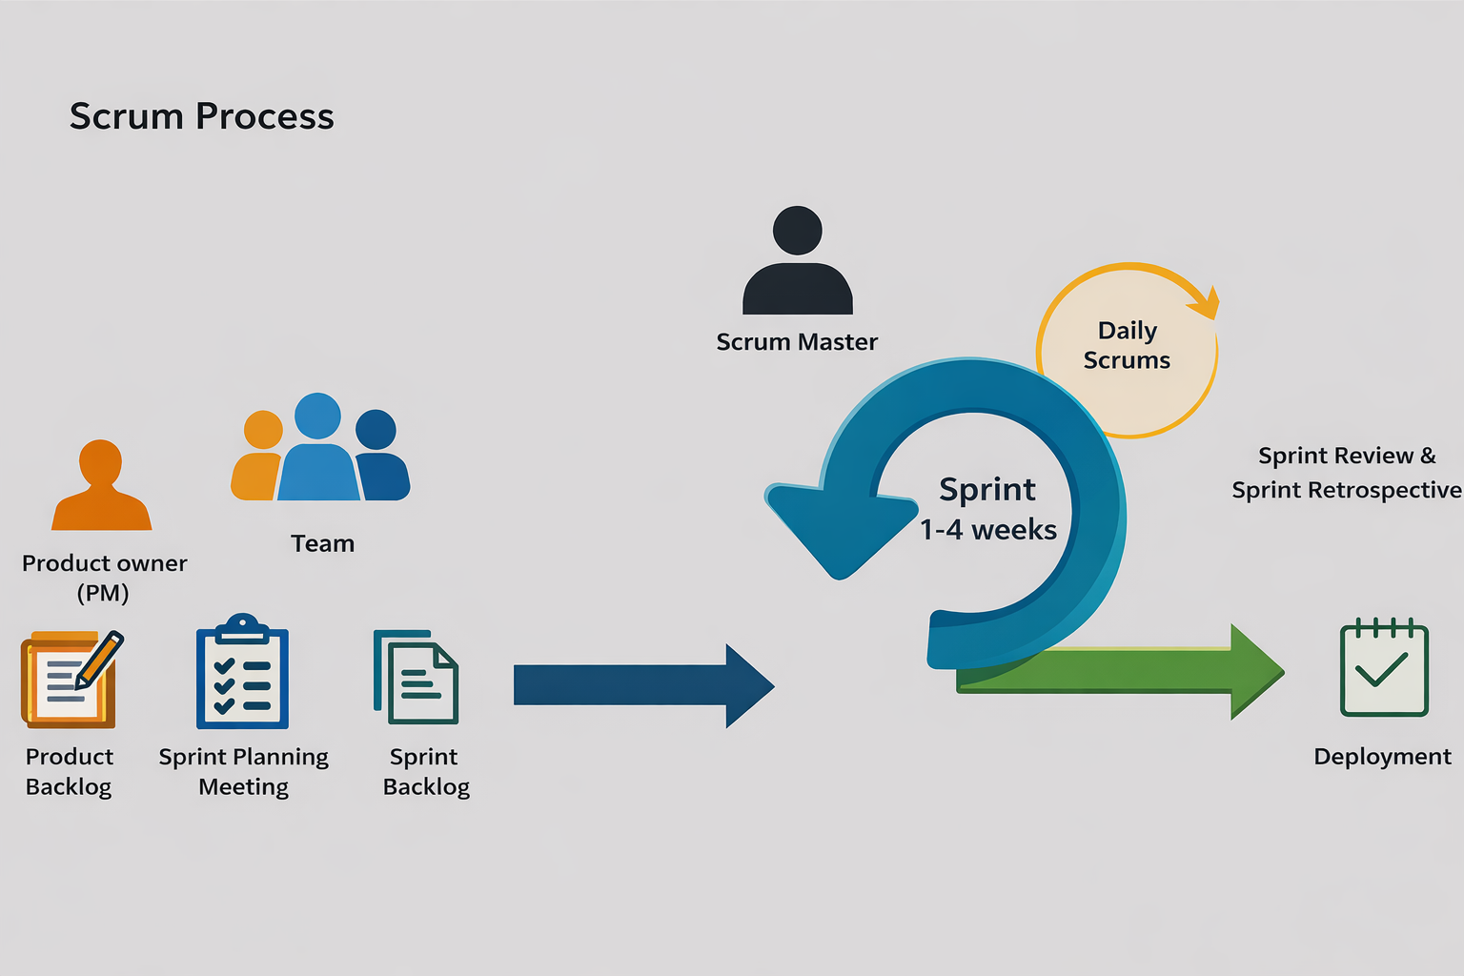

Figure 1: Agile Methodology – Scrum Model Process by Ken Schwaber
and Jeff Sutherland
As shown in Figure 1, the researchers have chosen the Scrum-Agile model for the project because it supports an adaptive and collaborative development approach. Working in short, iterative sprints allows for continuous feedback and improvement, reducing risks and ensuring steady progress. This approach also offers a flexible structure that future teams can use when developing dynamic and user-centered systems.
The project, “Office Student Affairs (OSA) Management System with QR Code and Geotagging System for Student Activity and Attendance” adopts the Scrum Agile model illustrated in Figure 1. This methodology organizes development into short, focused work sessions called sprints, enabling step-by-step system development. Scrum follows distinct phases, including Product Backlog Creation, Sprint Planning, Sprint Backlog, Sprint Review, and Sprint Retrospective, ensuring that all requirements are regularly reviewed and adjusted to meet evolving needs.

3.1 Overview of the Methodology
The development of the Office Student Affairs (OSA) Management System with QR Code and Geotagging System for Student Activity and Attendance adopts the Agile Software Development Methodology, specifically the Scrum Framework, to ensure the systematic design, implementation, testing, and continuous improvement of the proposed system. Agile Scrum is an iterative and incremental software development methodology that emphasizes flexibility, collaboration, stakeholder involvement, and the rapid delivery of functional software increments (Schwaber & Sutherland, 2020). Unlike traditional software development models such as the Waterfall Model, which follows a rigid sequential process, Agile Scrum enables the development team to divide the project into smaller iterations called sprints. Each sprint delivers a functional increment of the system that can be reviewed, tested, and evaluated by stakeholders before proceeding to the next development cycle. This iterative approach allows the researchers to identify technical issues early, accommodate changing user requirements, and continuously improve the system based on stakeholder feedback.
The Scrum Framework also promotes close collaboration among the development team, Product Owner, and stakeholders throughout the software development lifecycle. Continuous sprint planning, daily Scrum meetings, sprint reviews, and sprint retrospectives enable the researchers to monitor project progress, resolve issues efficiently, and ensure that every system feature satisfies the operational requirements of the Office of Student Affairs.
The researchers selected Agile Scrum because the proposed system consists of multiple integrated modules including QR code attendance monitoring, geotagging validation, admission slip processing, student case record management, activity evaluation, analytics, and automated e-certificate generation which require iterative development, continuous integration, and regular stakeholder validation. Through Agile Scrum, the researchers can progressively deliver working software, refine system functionalities, and maintain software quality while ensuring that the final system effectively addresses the needs of the Office of Student Affairs of St. Rita's College of Balingasag.

3.2 Research Design
This study employs a Developmental-Applied Research Design integrated with a Descriptive-Quantitative Research Method to address the operational challenges encountered by the Office of Student Affairs (OSA) of St. Rita's College of Balingasag in managing student activities, attendance monitoring, admission slip processing, evaluation management, student case records, and report generation. The developmental-applied component focuses on the systematic design, development, implementation, and testing of the Office Student Affairs (OSA) Management System with QR Code and Geotagging System for Student Activity and Attendance. The software development process follows the Agile Scrum Methodology, allowing the researchers to perform iterative planning, requirement analysis, system design, software development, continuous integration, testing, and stakeholder validation through structured sprint cycles. This approach supports incremental software delivery, accommodates changing user requirements, and promotes continuous improvement based on stakeholder feedback throughout the development process (Richey & Klein, 2007; Schwaber & Sutherland, 2020).
The descriptive-quantitative component focuses on evaluating the quality, usability, functionality, and overall acceptability of the developed system. Quantitative data will be collected through User Acceptance Testing (UAT) involving the target users, including the Office of Student Affairs personnel, Program Heads, Central Student Government (CSG) Officers, and students. The system will also be evaluated by Information Technology experts using the ISO/IEC 25010 Software Quality Model, while system usability will be measured using the System Usability Scale (SUS). The collected data will be analyzed using descriptive statistical methods, such as frequency counts, percentages, weighted mean, and interpretation scales, to determine the overall performance and user acceptance of the proposed system. The Developmental-Applied Research Design is appropriate for this study because its primary objective is to produce a functional technological solution while simultaneously evaluating its effectiveness, usability, and software quality within an actual institutional environment. This design enables the researchers to develop an innovative student affairs management system that responds to identified operational problems while providing empirical evidence regarding its quality and user acceptance.

3.3 Agile Scrum Framework
The development of the Office Student Affairs (OSA) Management System with QR Code and Geotagging System for Student Activity and Attendance follows the Agile Scrum Framework to organize software development into iterative and incremental cycles. Scrum enables the researchers to develop the system through a series of short development periods called sprints, allowing continuous planning, development, testing, evaluation, and stakeholder feedback throughout the project. This framework promotes collaboration, flexibility, and continuous improvement, ensuring that each completed sprint delivers a functional system increment that contributes to the final product (Schwaber & Sutherland, 2020).
The Scrum Framework implemented in this study consists of Scrum Roles, Scrum Artifacts, Scrum Events, and Sprint Cycles, which collectively guide the systematic development of the proposed system.
3.3.1 Scrum Roles
The Scrum team for this study consists of the Product Owner, Scrum Master, Development Team, and Stakeholders. Each role has specific responsibilities to ensure the successful development of the proposed system.
Scrum Role | Assigned Personnel | Responsibilities
Product Owner | Office of Student Affairs (OSA) Representative | Defines system requirements, prioritizes the Product Backlog, validates completed features, and provides feedback during Sprint Reviews.
Scrum Master | Project Manager (Researcher) | Facilitates Scrum activities, monitors sprint progress, removes development obstacles, and ensures proper implementation of Agile Scrum practices.
Development Team | Researchers/ Developers | Designs, develops, tests, integrates, and documents the system throughout every sprint.
Stakeholders | OSA Personnel, Program Heads, CSG Officers, Students | Evaluate developed features, provide feedback, participate in User Acceptance Testing, and validate system requirements.

3.3.2 Scrum Artifacts
Product Backlog
The Product Backlog contains all system requirements gathered during interviews, observations, and stakeholder consultations. It serves as the master list of system features that will be prioritized and implemented throughout the project.
The Product Backlog of this study includes:
- User Authentication
- User Management
- QR Code Attendance
- Geotagging Validation
- Admission Slip Processing
- Student Case Records
- Activity Evaluation
- Analytics Dashboard
- Report Generation
- E-Certificate Generation
- Role-Based Access Control
- Activity Log Monitoring
- Archive Management
Sprint Backlog
The Sprint Backlog contains selected Product Backlog items that will be completed during a specific sprint. Each Sprint Backlog includes development tasks, testing activities, and expected deliverables. Before each sprint begins, the development team conducts Sprint Planning to determine the features to be implemented based on project priorities and stakeholder requirements.
Working System Increment
At the end of every sprint, a functional version of the system is produced. This working increment undergoes Sprint Review, stakeholder evaluation, and testing before proceeding to the next sprint. Feedback gathered during Sprint Review is incorporated into the succeeding sprint to continuously improve the system.
3.3.3 Scrum Events
The Scrum Framework follows several recurring activities throughout the development process.
- Sprint Planning – determines sprint goals and identifies Product Backlog items to be completed.
- Daily Scrum – short meetings to monitor progress, discuss completed tasks, identify obstacles, and plan daily activities.
- Sprint Review – demonstrates completed features to stakeholders and gathers recommendations.
- Sprint Retrospective – evaluates the sprint process and identifies improvements for future iterations.
3.3.4 Sprint Cycles
The researchers divided the project into three development sprints, each lasting three (3) weeks, allowing adequate time for planning, development, testing, integration, and stakeholder validation.
Sprint | Duration | Major Deliverables
Sprint 1 | 3 weeks | Admin Module, User Authentication, User Management, Dashboard, Role-Based Access Control, Event Management
Sprint 2 | 3 weeks | Student Module, QR Code Attendance, Geotagging Validation, Admission Slip Requests, Activity Evaluation
Sprint 3 | 3 weeks | Program Head Module, Student Case Records, Analytics Dashboard, Reports, E-Certificate Generation, Final Testing and Deployment
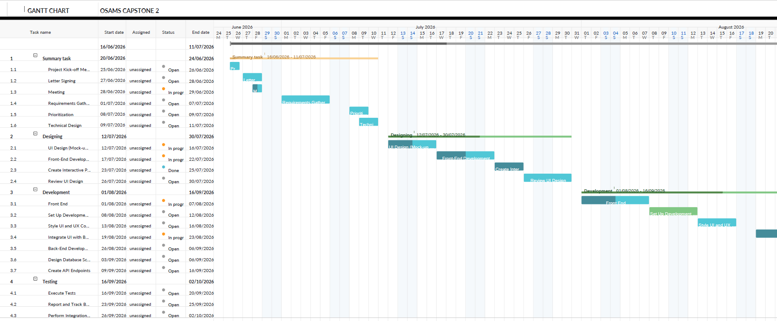
3.3.5 Gantt Chart

Figure 2: Project Gantt Chart
The Gantt Chart presents the overall project schedule adopted by the researchers throughout the software development process. It illustrates the sequence and duration of major activities, including requirement gathering, sprint planning, interface design, system development, testing, deployment, documentation, and project evaluation. The chart also demonstrates how Agile Scrum activities overlap throughout the project. Each sprint includes planning, development, testing, review, and retrospective activities, ensuring that every completed module undergoes continuous validation before proceeding to the succeeding sprint.

3.4 System Design and Modeling
System design and modeling provide the structural and functional blueprint of the proposed system. The diagrams presented in this section illustrate the architecture, data movement, business processes, database structure, user interfaces, and testing procedures used during the development of the Office Student Affairs (OSA) Management System with QR Code and Geotagging System for Student Activity and Attendance. These models enable the researchers to visualize system components, define interactions among users and processes, and ensure that the system satisfies the identified functional and non-functional requirements.

3.4.1 System Architecture Diagram
This section presents the system modeling and design artifacts that describe how the proposed system operates, how data flows through its components, and how users interact with its features. These diagrams are created using draw.io and related tools and serve as visual documentation of the system’s processes, architecture, and data structures.
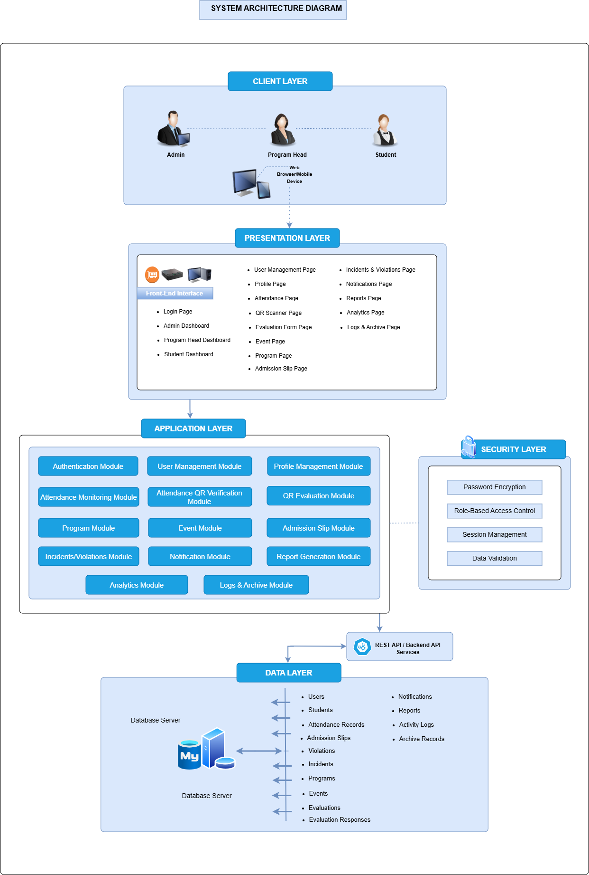

Figure 3 : System Architecture
As shown in Figure 3, the System Architecture of the Office of Student Affairs Management System (OSAMS) is designed using a multi-layered architecture that promotes scalability, security, maintainability, and efficient management of student affairs processes. At the Client Layer, the primary users; Admin, Program Head, and Students access the system through web browsers or mobile devices, allowing convenient and flexible interaction with the platform. User requests are then directed to the Presentation Layer, which serves as the front-end interface and includes pages such as Login, Admin Dashboard, Program Head Dashboard, Student Dashboard, User Management, Profile Management, Attendance Monitoring, QR Scanner, Evaluation Forms, Events, Programs, Admission Slips, Incidents and Violations, Notifications, Reports, Analytics, and Logs and Archive pages. This layer provides an intuitive and responsive environment for users to perform their respective tasks.
The Application Layer functions as the core processing component of the system, where business logic and system functionalities are implemented. It consists of modules such as Authentication, User Management, Profile Management, Attendance Monitoring, Attendance QR Verification, QR Evaluation, Program Management, Event Management, Admission Slip Processing, Incidents and Violations Management, Notification Management, Report Generation, Analytics, and Logs and Archive Management. These modules work together to automate and streamline student affairs operations while ensuring accurate processing of data and transactions. Supporting this layer is the Security Layer, which enhances system protection through password encryption, role-based access control, session management, and data validation, ensuring that only authorized users can access sensitive information and system resources.
To facilitate communication between the application and the database, the architecture utilizes REST API/Backend API Services, enabling secure and efficient data exchange among system components. At the Data Layer, all information is stored and managed within a MySQL database server. The database contains records related to users, students, attendance, admission slips, violations, incidents, programs, events, evaluations, evaluation responses, notifications, reports, activity logs, and archived records. This centralized repository ensures data consistency, integrity, and real-time availability of information. Overall, the layered architecture of OSAMS provides a comprehensive and secure framework that integrates multiple student affairs functions into a single platform, improving operational efficiency, decision-making, and service delivery within the institution.

3.4.2 Data Flow Diagrams (DFD)
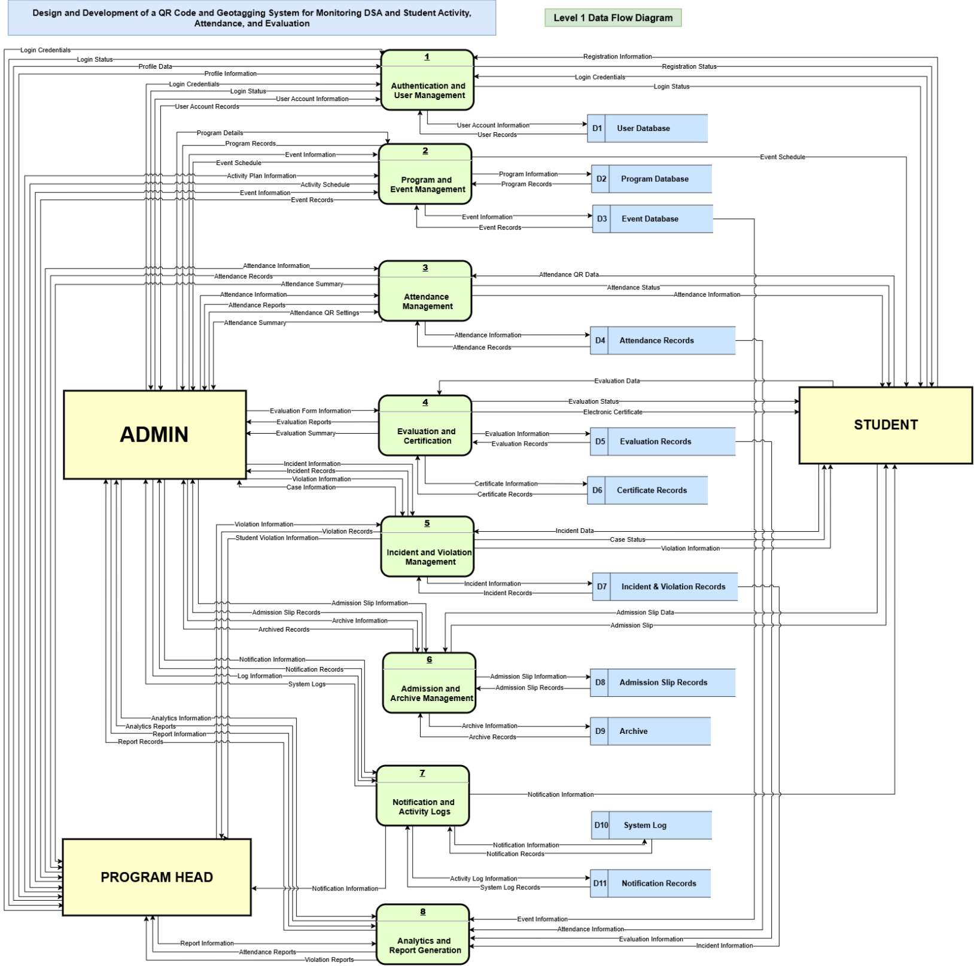
The Data Flow Diagram (DFD) illustrates how data moves within the system. It shows the sources of data, processes that transform the data, data storage, and outputs. This diagram helps in understanding how information such as attendance records, case details, and evaluation results are processed and stored within the system.

Figure 4 : Level 1 Data Flow Diagram
The Level 1 Data Flow Diagram shown in Figure 4 illustrates how data flows between the Admin, Student, Program Head, system processes, and data stores of the proposed system. The system begins with Authentication and User Management, which handles user registration, login credentials, profiles, and account information. It then processes the different system functions, including Program and Event Management, Attendance Management, Evaluation and Certification, Incident and Violation Management, Admission and Archive Management, Notification and Activity Logs, and Analytics and Report Generation. Each process manages specific information and stores it in the appropriate data stores, such as the User Database, Program Database, Event Database, Attendance Records, Evaluation Records, Certificate Records, Incident and Violation Records, Admission Slip Records, Archive, System Log, and Notification Records. The Admin, Student, and Program Head interact with the system by sending and receiving information according to their respective roles and authorized activities. Overall, the diagram shows how data is processed, stored, retrieved, and transferred throughout the different components of the proposed system.
3.4.3 Activity Diagrams
The Activity Diagrams illustrate the sequence of activities, actions, and interactions involved in the different processes of the Office of Student Affairs. They show how each process is currently performed and how it will be improved through the proposed system. The current activity diagrams present the existing procedures for student attendance, activity evaluation, admission slip requests, and the handling of incidents, violations, and complaints. These include paper-based and online-based activity evaluations, walk-in admission slip processing, and different procedures for minor and serious cases. Meanwhile, the proposed activity diagrams present the improved processes for student attendance, activity evaluation, admission slips, and the management of minor and serious incidents, violations, and complaints using the proposed system. These diagrams provide a clear comparison between the existing and proposed workflows and show how the system can improve the efficiency and management of these processes.

3.4.3.1 Current Activity Diagrams
The Current Activity Diagrams present the existing procedures followed by the students and the Office of Student Affairs (OSA) in carrying out different student-related activities. These diagrams show the current flow of student attendance, activity evaluation, admission slip requests, and incident, violation, and complaint handling. The processes include paper-based and online-based activity evaluations, walk-in admission slip requests, and separate procedures for minor cases based on complaints, being caught in the act, or witness reports, as well as serious cases or concerns that arise. These diagrams serve as a representation of the existing processes before the implementation of the proposed system.
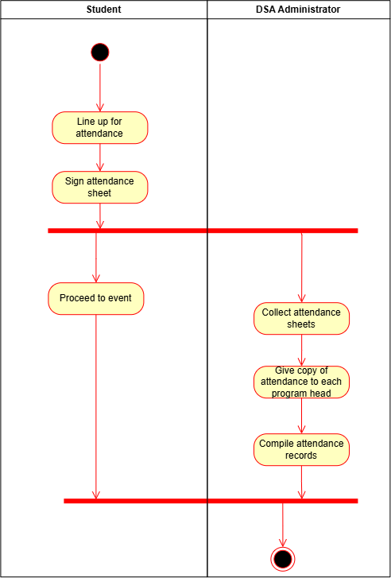

Figure 5: Current Student Attendance Activity Flow Diagram
As shown in Figure 5, the current student attendance workflow in the Office of Student Affairs (OSA) Office process begins with students arriving at the venue and lining up for attendance. Each student then signs the attendance sheet to confirm their presence. After completing the sign-in process, students proceed to the event. On the administrative side, the OSA administrator collects all completed attendance sheets after the sign-in period. Copies of the attendance records are then distributed to each program head for reference and monitoring. Following this, the administrator compiles the attendance data into an organized record for documentation and reporting purposes. The workflow concludes once all attendance records have been properly compiled and finalized.

Figure 6: Current Paper-Based Evaluation Activity Flow Diagram
The current paper-based activity evaluation workflow that is shown in Figure 3, involving the OSA Administrator, students, and the research office. The process begins with the OSA administrator distributing evaluation forms to students. Upon receiving the forms, students fill out and answer the evaluation questions, then submit the completed forms back to the administrator. After collecting all evaluation responses, the OSA administrator consolidates the results and prepares them for further analysis. These prepared evaluation results are then forwarded to the research office, where they are carefully analyzed to extract meaningful insights. Once the analysis is complete, the research office returns the evaluation findings to the OSA office. Lastly, the OSA administrator utilizes the analyzed results to generate reports, concluding the evaluation process.
3.4.3.2 Proposed Activity Diagrams
The Proposed Activity Diagrams present the improved procedures that will be implemented through the proposed system. These diagrams show how the system will support and streamline the processes for student attendance, activity evaluation, admission slip requests, and the management of minor and serious incidents, violations, and complaints. The proposed workflows incorporate system-based processes such as recording information, sending notifications, updating statuses, and managing records to reduce manual work and improve the efficiency of OSA services. These diagrams demonstrate how the proposed system improves the existing procedures while providing a more organized and efficient process for both students and authorized OSA personnel.

3.4.4 Database Design (ERD & Data Dictionary)
3.4.5 User Interface (UI/UX) Design & Wireframes
3.4.6 System Testing and Evaluation Plan
3.4.7 User Interface (UI/UX) Design & Wireframes

CHAPTER 4

